**NAME: GVS SAI MADHAV**

**REG.NO: 19BCN7228**

**LAB-4:**

**Q1:** Write a program in java to display four different images of a given URL in a single frame as four quadrants. The images should change from one quadrant to other quadrant in a cyclic manner, with 5 secs delay

**Code:**

import java.awt.Color;

import java.awt.Dimension;

import java.awt.Graphics;

import java.awt.event.ActionEvent;

import java.awt.event.ActionListener;

import java.awt.image.BufferedImage;

import java.awt.*;

import java.io.IOException;

import java.net.MalformedURLException;

import java.net.URL;

import java.util.Random;

import javax.imageio.ImageIO;

import javax.swing.JFrame;

import javax.swing.JPanel;

import javax.swing.SwingUtilities;

import javax.swing.Timer;

import javax.swing.*;

public class Main {

public static void main(String[] args) {

SwingUtilities.invokeLater(new Runnable(){

@Override

public void run() {

JFrame frame = new JFrame("Image Timer");

frame.add(new ImagePanel());

frame.setDefaultCloseOperation(JFrame.EXIT_ON_CLOSE);

frame.pack();

frame.setLocationRelativeTo(null);

frame.setVisible(true);

}

});

}

private static class ImagePanel extends JPanel {

URL[] urls;

Image[] images;

Random rand = new Random();

public ImagePanel() {

urls = new URL[4];

try {

urls[0] = new URL(" https://cdn-dmpbo.nitrocdn.com/sTfxmDcplhzyoBVcguAegkZcSjDCGcXk/assets/static/source/rev-19bfa43/wp-content/uploads/2019/09/gopinath.jpg");

urls[1] = new URL(" https://vitap.ac.in/wp-content/uploads/2020/07/Dr.-HUSSAIN-SYED.jpg");

urls[2] = new URL(" https://cdn-dmpbo.nitrocdn.com/sTfxmDcplhzyoBVcguAegkZcSjDCGcXk/assets/static/source/rev-19bfa43/wp-content/uploads/2019/06/Dr.-SUDHAKAR-ILANGO-1.jpg");

urls[3] = new URL(" https://vitap.ac.in/wp-content/uploads/2019/06/Dr.-S.-SIBI-CHAKRAVARTY.jpg");

images = new Image[4];

images[0] = ImageIO.read(urls[0]);

images[1] = ImageIO.read(urls[1]);

images[2] = ImageIO.read(urls[2]);

images[3] = ImageIO.read(urls[3]);

} catch (MalformedURLException ex) {

ex.printStackTrace();

} catch (IOException ex) {

ex.printStackTrace();

}

setBackground(Color.BLACK);

Timer timer = new Timer(5000, new ActionListener(){

@Override

public void actionPerformed(ActionEvent e) {

repaint();

}

});

timer.start();

}

//static int a[] = {0,1,2,3};

@Override

protected void paintComponent(Graphics g) {

super.paintComponent(g);

g.setColor(Color.WHITE);

g.drawImage(images[0], 0, 0,200,200, this);

g.drawImage(images[1], 200, 0,200,200, this);

g.drawImage(images[2], 0, 200,200,200, this);

g.drawImage(images[3], 200, 200,200,200, this);

Image temp=images[0];

for(int i=0;i<3;i++)

{

images[i]=images[i+1];

}

images[3]=temp;

}

@Override

public Dimension getPreferredSize() {

return new Dimension(1920, 1080);

}

}

}

**Output:**

**Initial:**

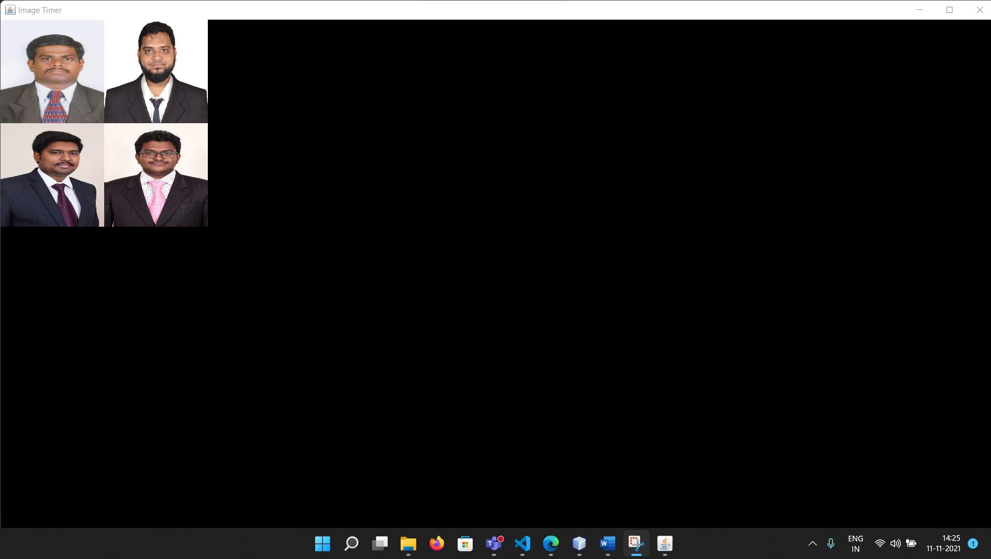

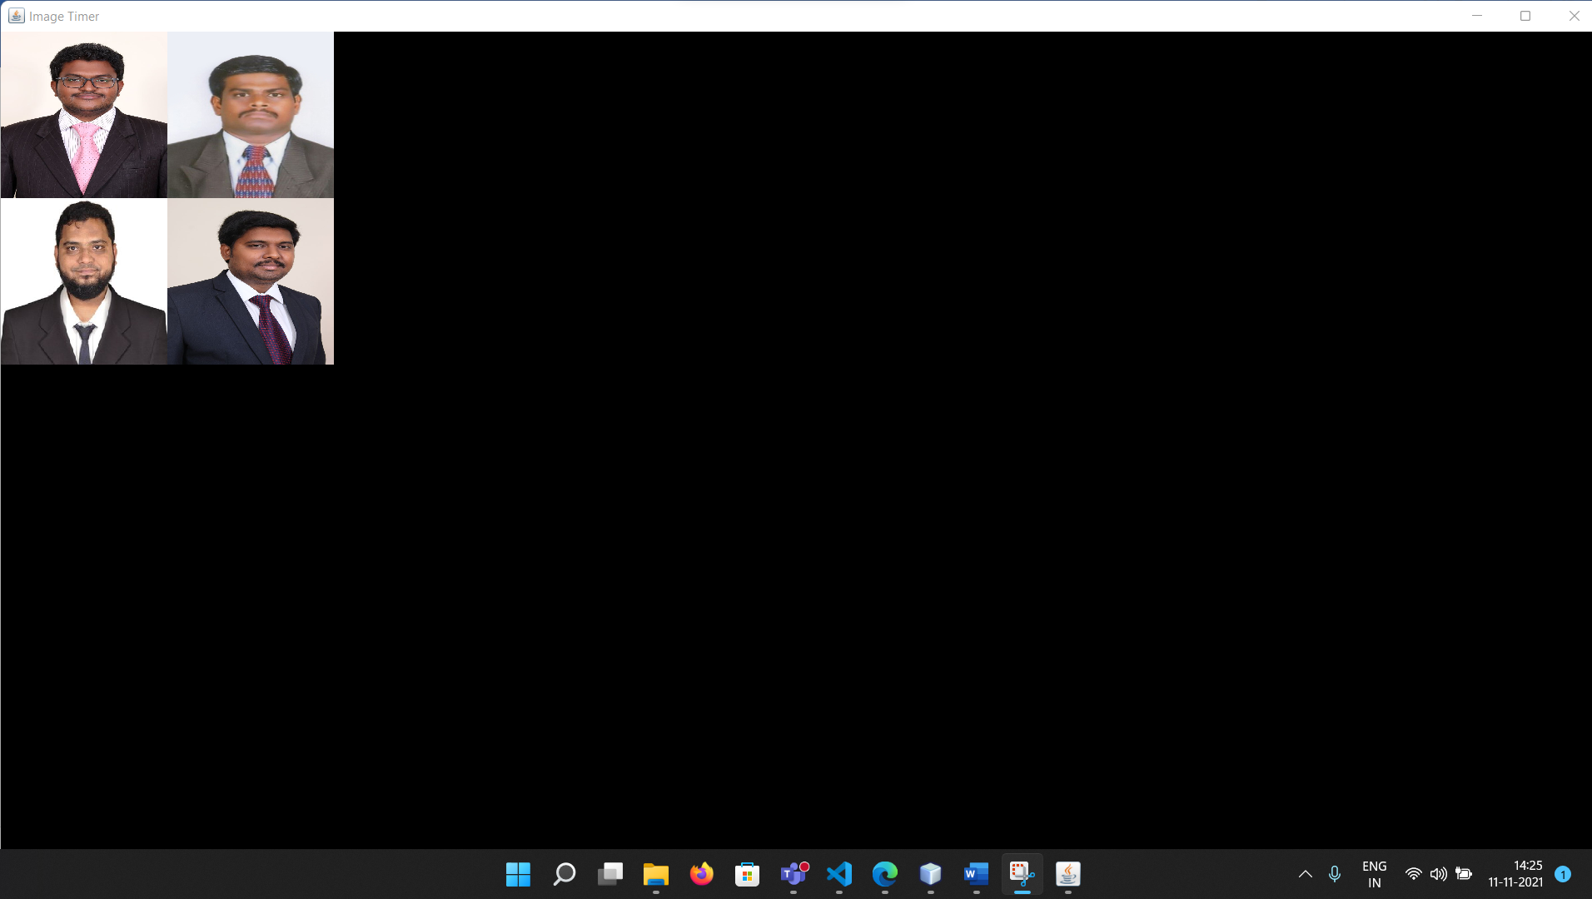

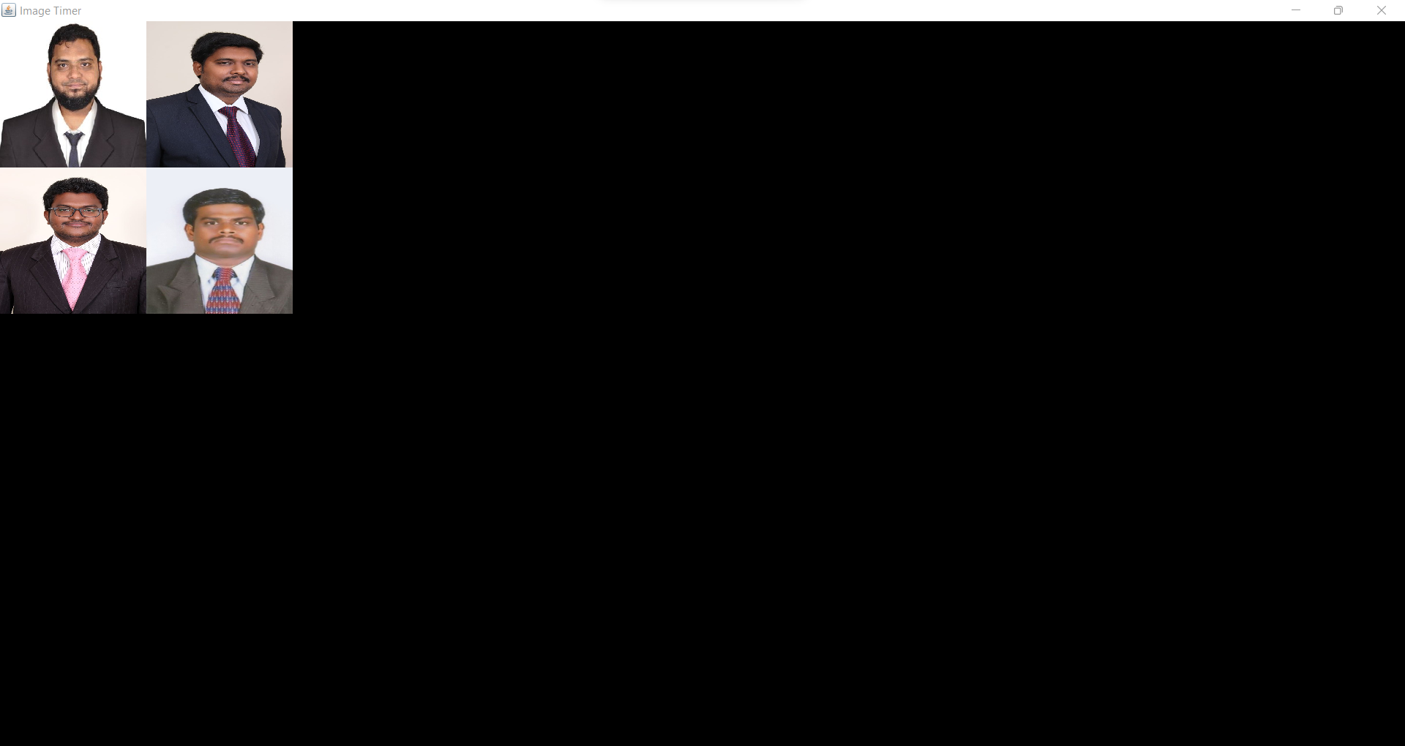

**Q2:**

read the information of the given url and count the number of vowels in it. Identify the most used word of the page.